**Project Report Specification**

**1. Title of the Project:** Pet’s House

**2. Brief description of the project**

My website will connect pet lovers together. They can take care of pets of other members when others have vacation or go on a business trip.

Also, in my website, people can adopt pets and get some tips which is helpful to take care of their pets.

**3. Sitemap**

**Structure of home page (project.html)**

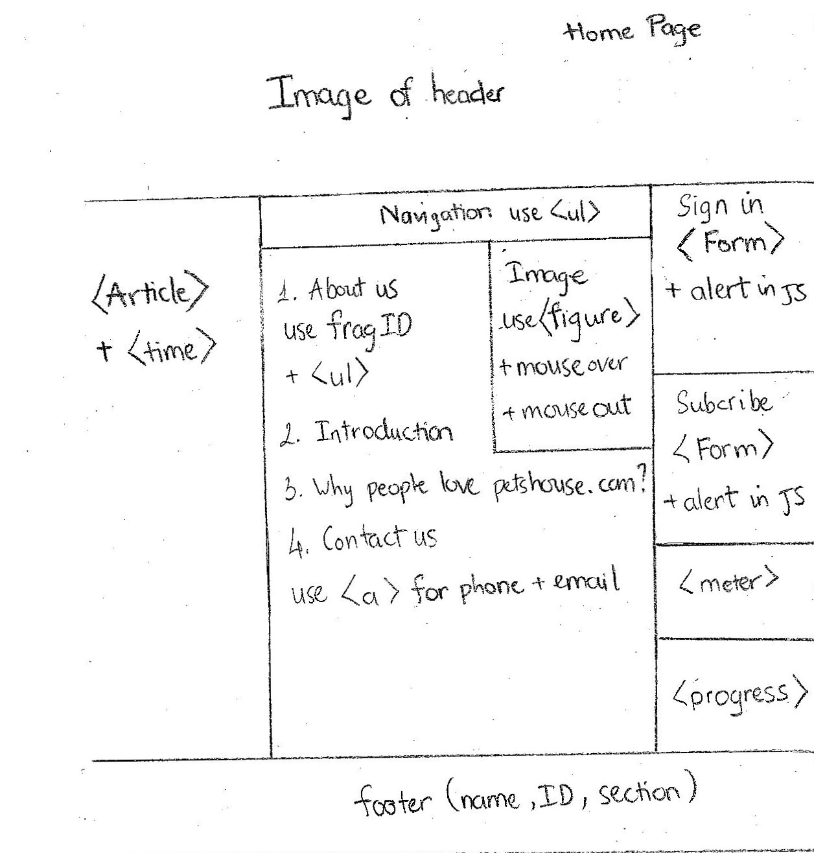

**Structure of dog page (Dogs.html)**

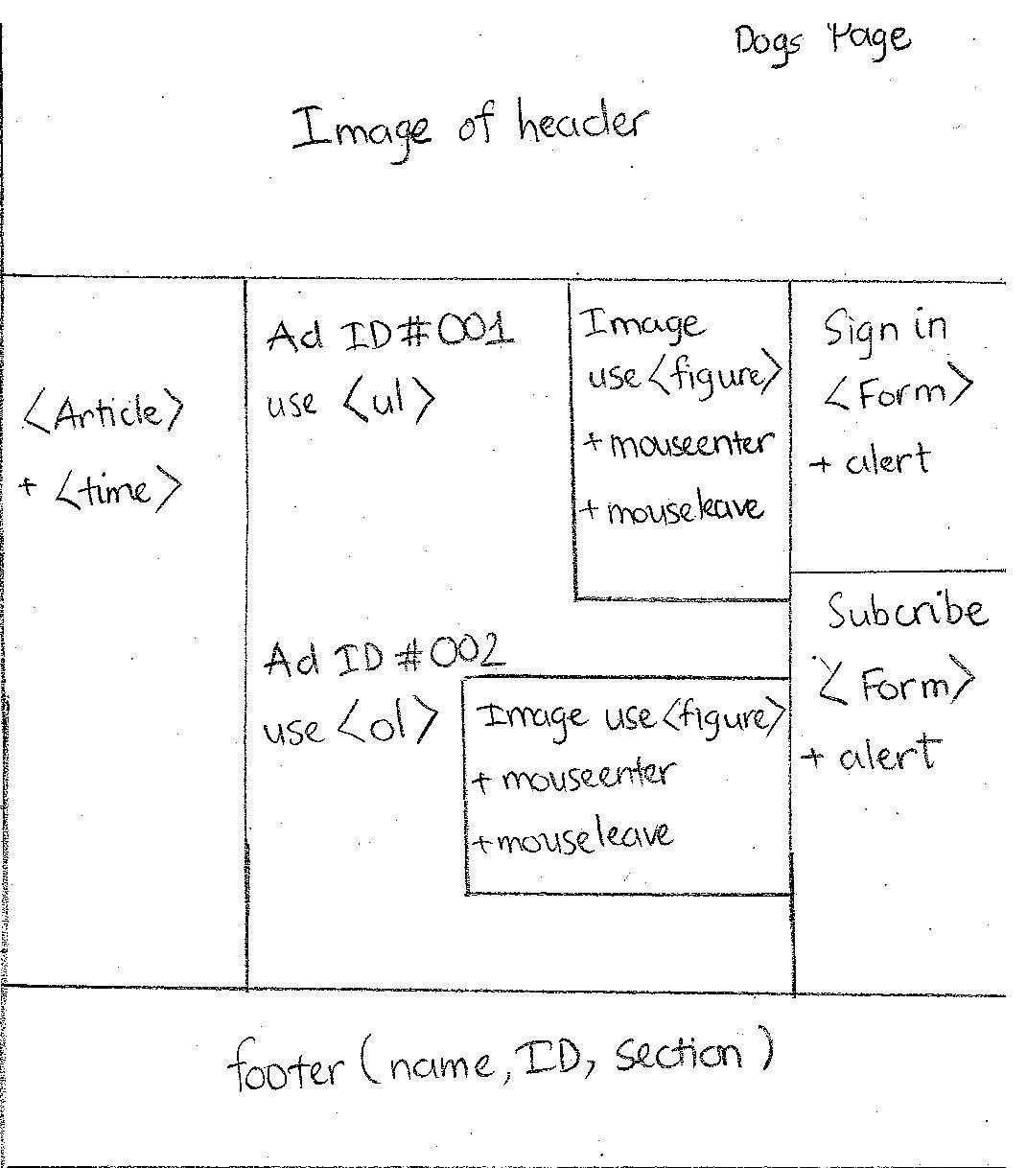

**Structure of cat page (Cats.html)**

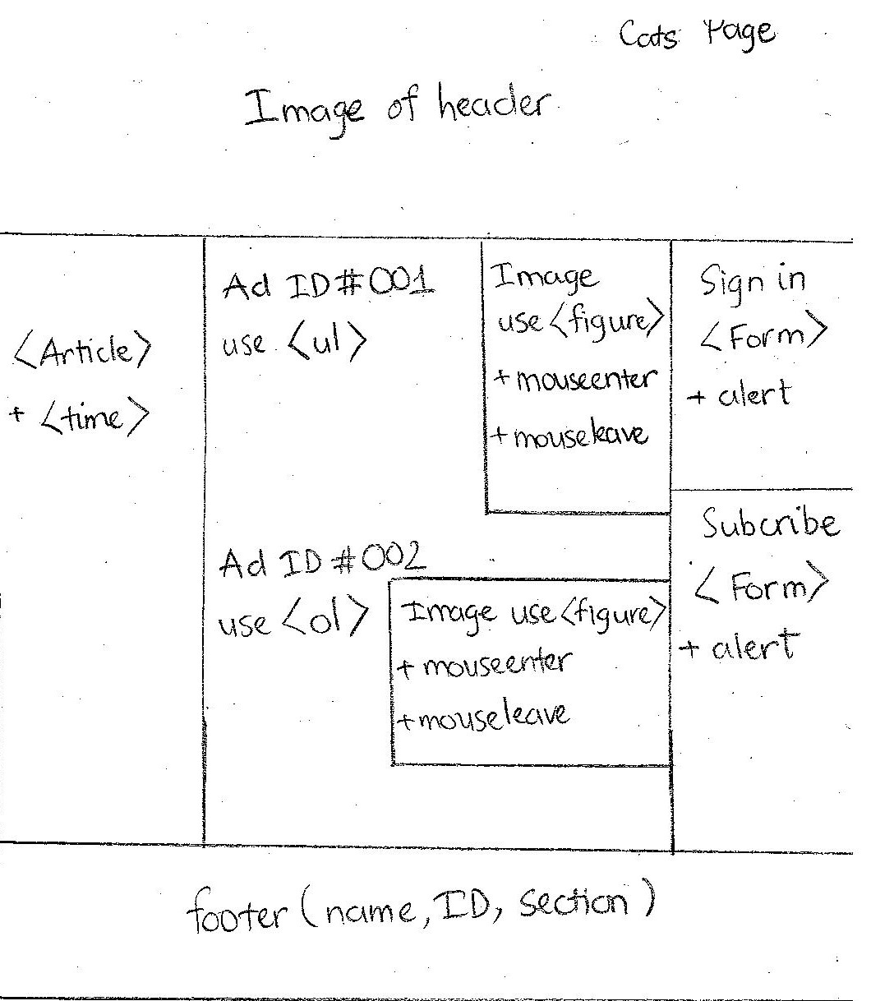

**Structure of tips page (Tips.html)**

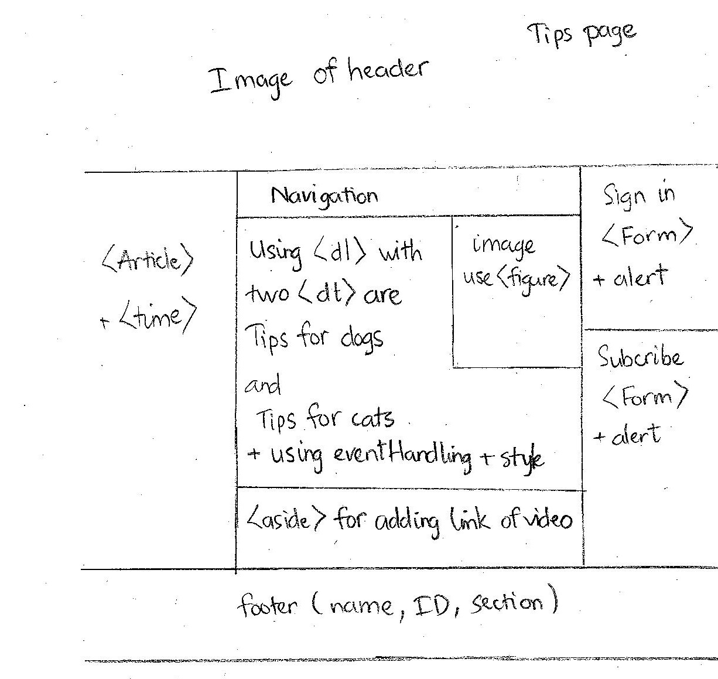

**Structure of pet sitter page (Pets_Sitter.html)**

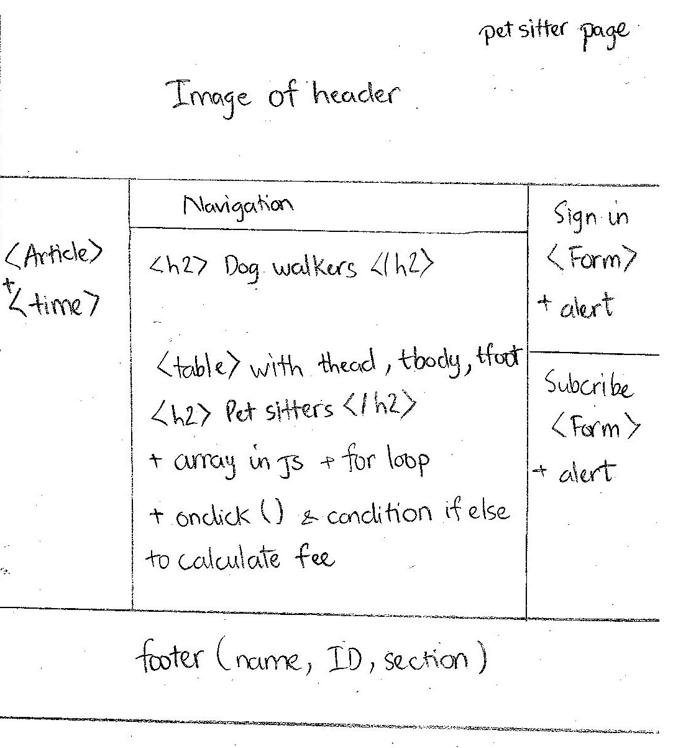

**Structure of registration page (Register.html)**

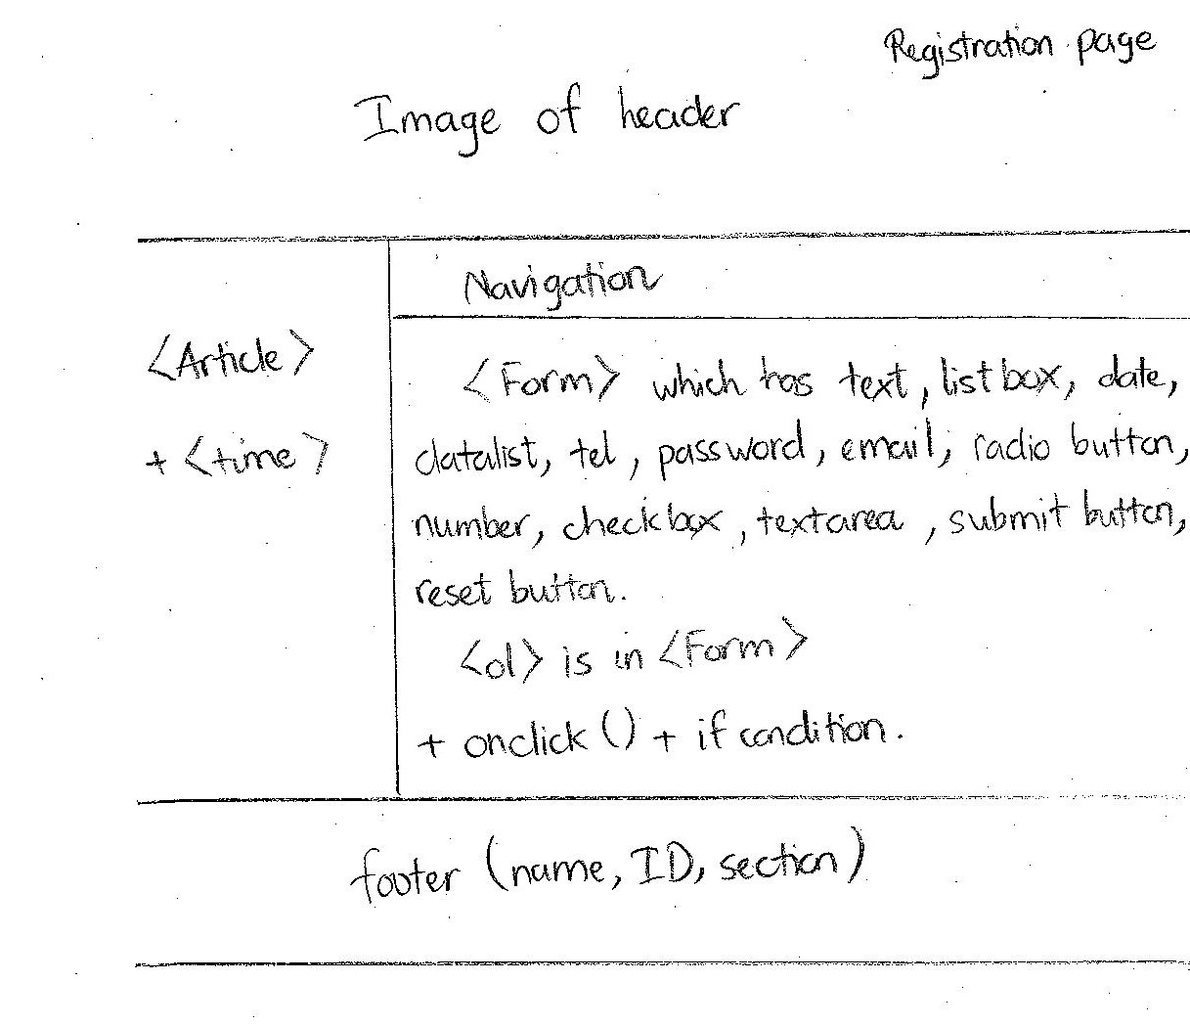

**References**

<http://hotdiggitypetsitting.com/vancouver/services/services-and-rates/>

<https://www.trustedhousesitters.com/>

<https://www.releasethehounds.ca/>

https://en.wikipedia.org/wiki/Catnip

<https://www.petmd.com/blogs/thedailyvet/jcoates/2011/june/cats_and_catnip-does_it_really_get_them_high_and_why-11271>

<https://www.kijiji.ca/b-dogs-puppies/vancouver/c126l1700287>

<https://www.petsmart.com/small-pet/live-small-pets/hamsters-guinea-pigs-and-more/long-haired-hamster-15341.html?cgid=600117>

<https://globalnews.ca/tag/pets/>

<https://www.dogster.com/lifestyle/understanding-dog-body-language>